Documentation

**Languages used:**

1. HTML , CSS , CSS3
2. Javascript , JQuery
3. Bootstrap Framework
4. Native PHP language
5. My SQl

**Overview** :

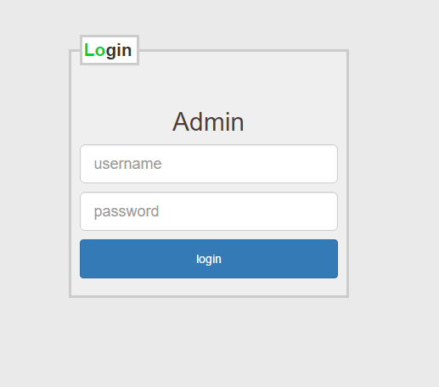

Where the user will enter his personal information needed to run the application in the way that is designed for.

1. The required information:
2. His username
3. His password

Now You will Sent to Dashboard which you can control you web App

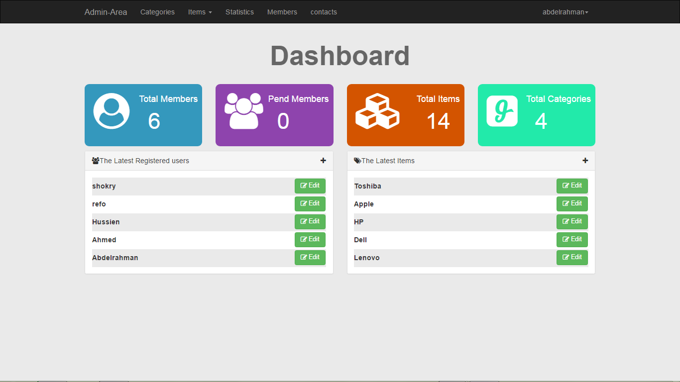

This you can control in adding a new member to your system

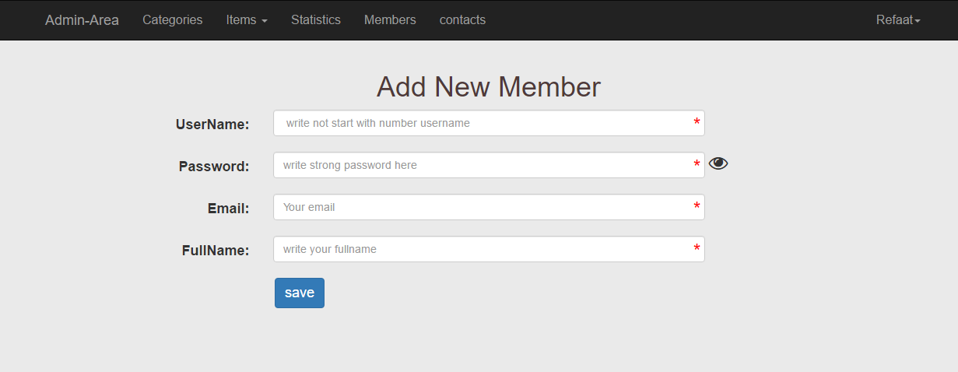

you can control in Editing a member in your company

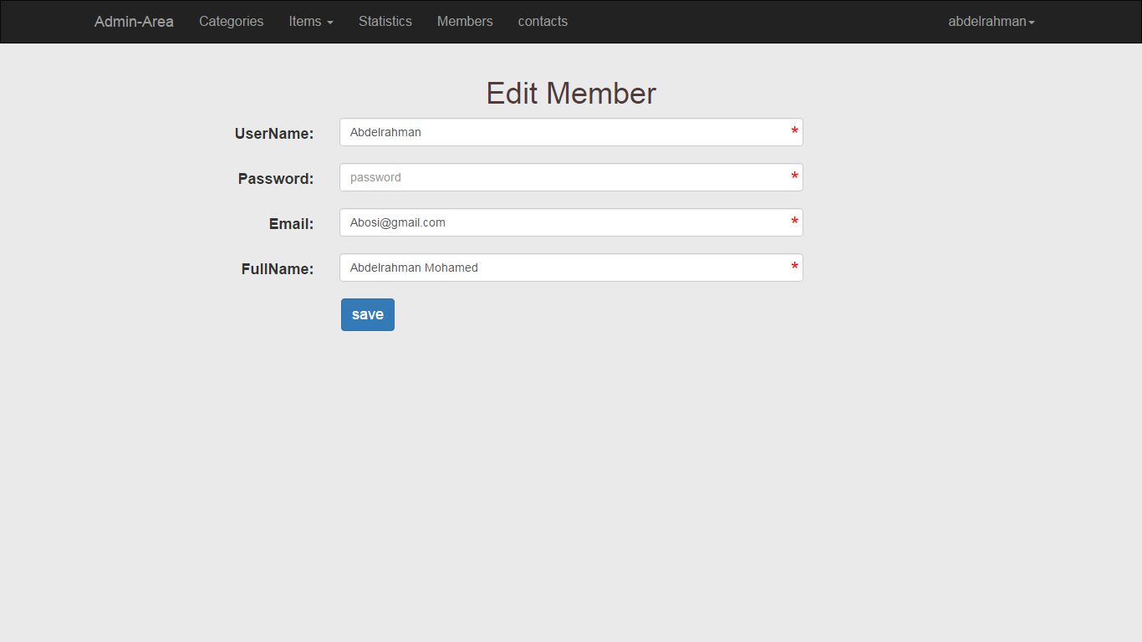

For Your Categories You can add or Edit or Delete a new category in your system

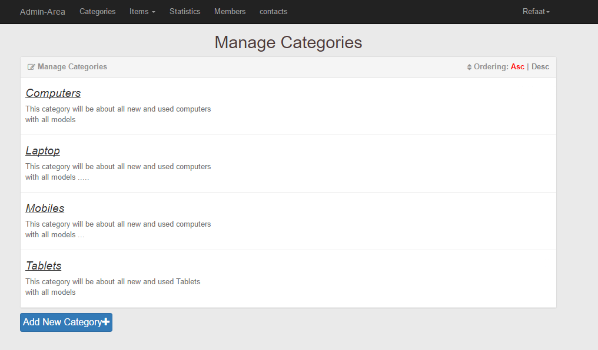

You can manage all items in a system

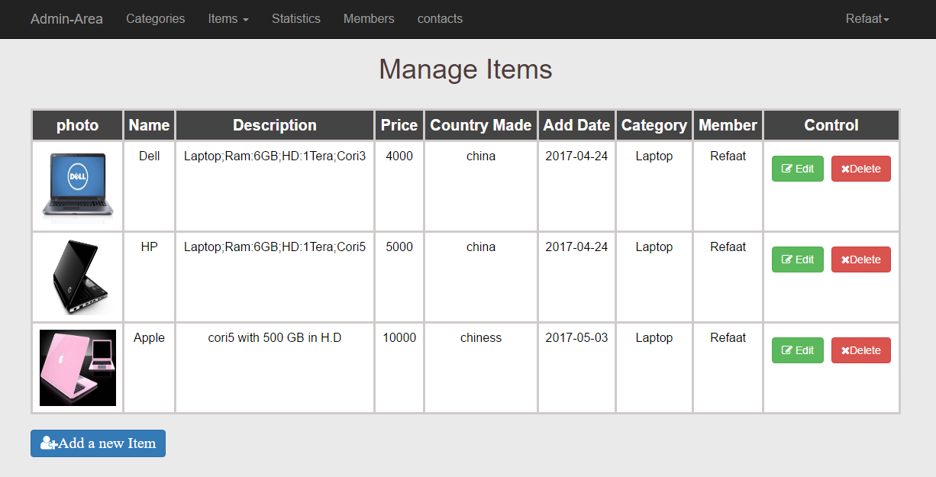

The ability to add a New Item by it’s required informations

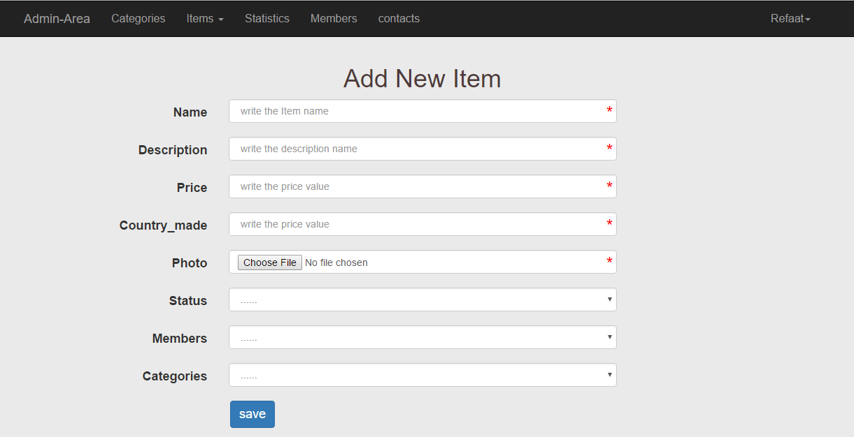

1-Name

2-Description

3-Price

4-Country Made

5-Photo for it

6-it’s status if used or new

7-Name of member which add this item

8-which any category belong to it

You can read the messages from End user in your APP

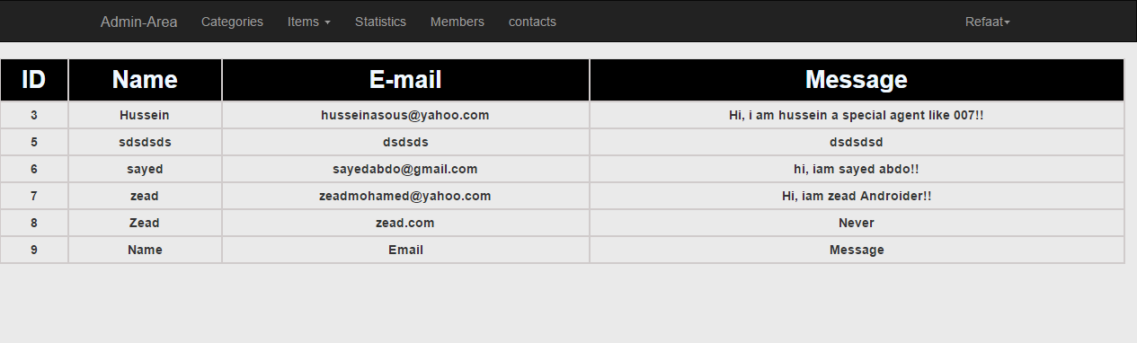

Now will talk about the features of client side

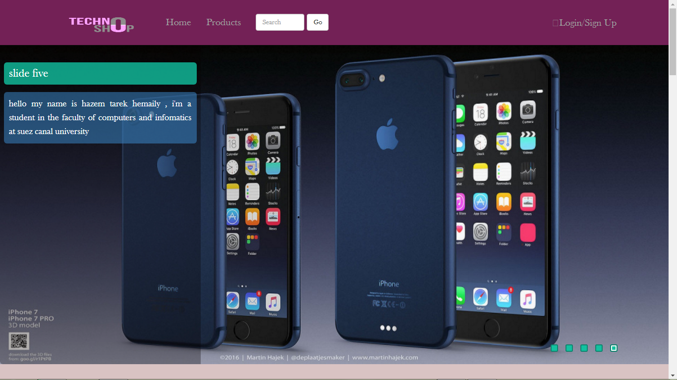

The Login Page

* + - When the user request to login he will send his email address and password , with the type of to Buy any item if he needs
    - The server will check the username and password if it is correct it will start a session for the user and store the user name and the ID of the user retrieved from the server database

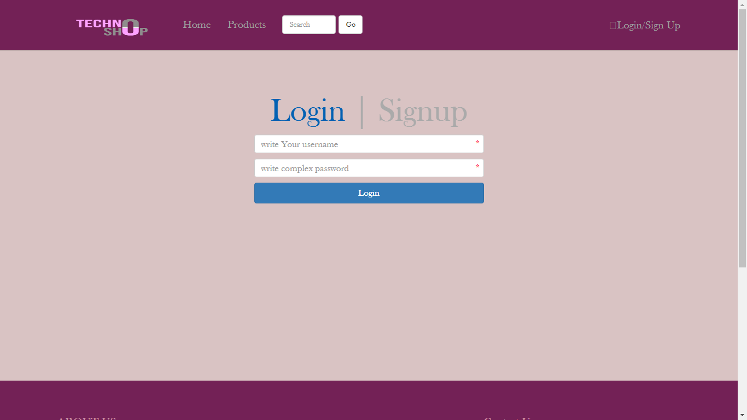

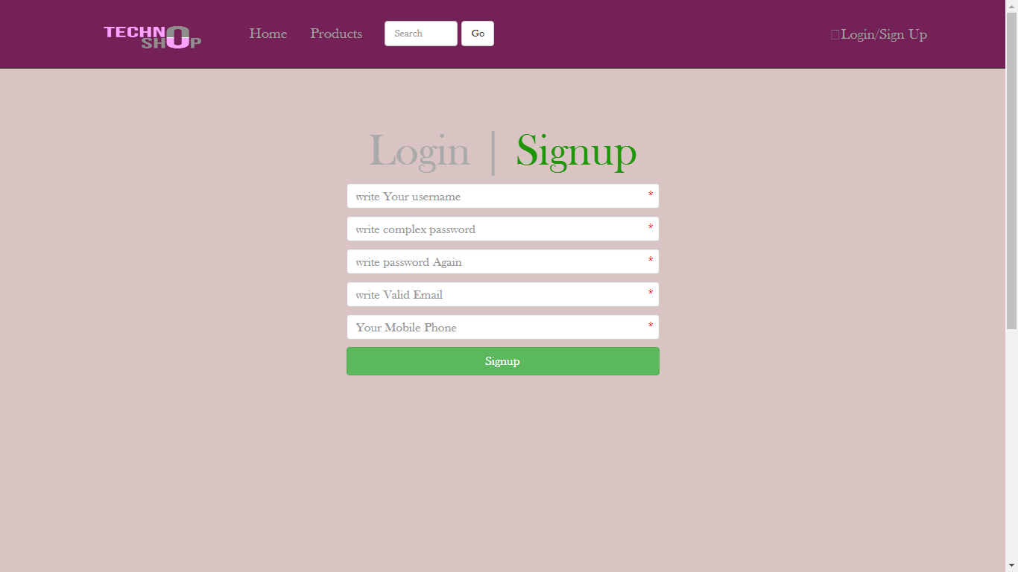

End users Can search any Item if he need with Price

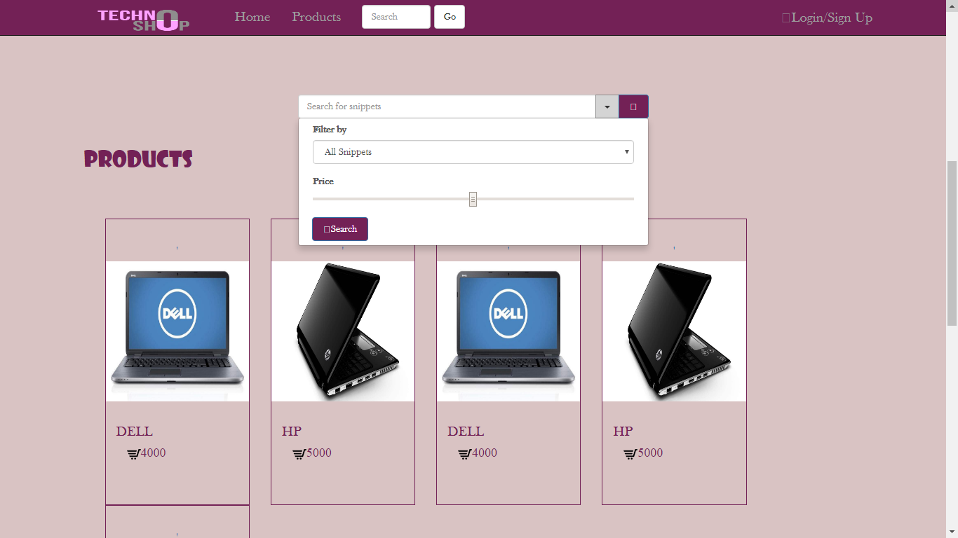

He can to contact with Admin which let a message in this Form

